**DAILY ONLINE ACTIVITIES SUMMARY**

|  |  |  |  |  |  |  |  |  |
| --- | --- | --- | --- | --- | --- | --- | --- | --- |
| **Date:** | **28-5-2020** | | | | | **Name:** | **poojashree** | |
| **Sem & Sec** | **8th sem A sec** | | | | | **USN:** | **4al16cs065** | |
| **Online Test Summary** | | | | | | | | |
| **Subject** | | **sms** | | | | | | |
| **Max. Marks** | | **60** | | **Score** | | | **60** | |
| **Certification Course Summary** | | | | | | | | |
| **Course** | **Introduction to hadoop** | | | | | | | |
| **Certificate Provider** | | | **Great learning academy** | | **Duration** | | | **3.5hr** |
| **Coding Challenges** | | | | | | | | |
| **Problem Statement:**  **1**.  **Pink Floyd and happiness in python** | | | | | | | | |
| **Status:completed** | | | | | | | | |
| **Uploaded the report in Github** | | | | | **yes** | | | |
| **If yes Repository name** | | | | | **Poojashree** | | | |
| **Uploaded the report in slack** | | | | | **yes** | | | |

**Online test**

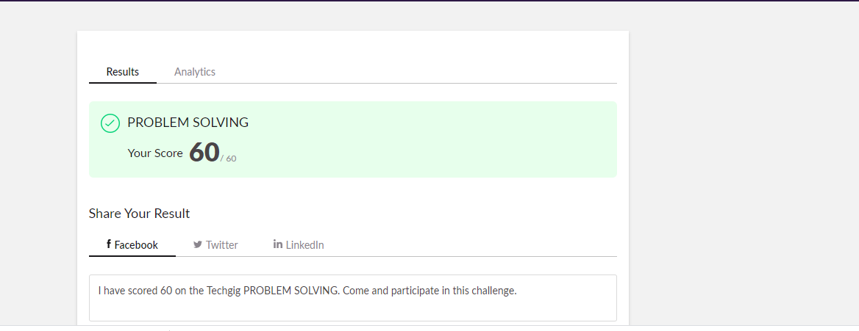

**Certification course**

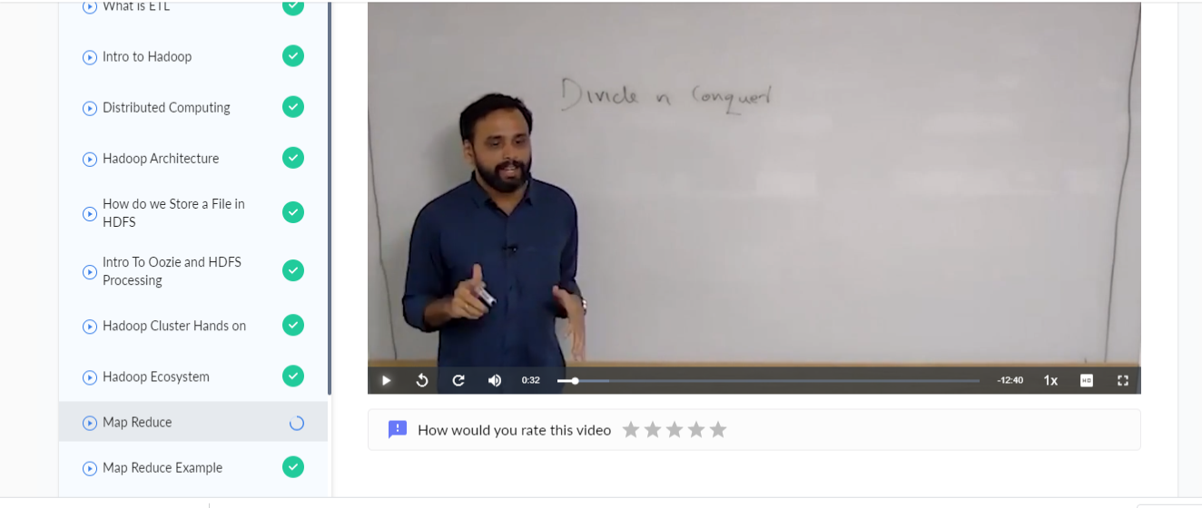

**Coding**

**Program 1**

**l=list()**

|  |
| --- |
| **s=list()** |
| **n=int(input())** |
| **for i in range(0,n):** |
| **m=int(input())** |
| **l.append(m)** |
| **s.append(i+1)** |
| **l.sort()** |
| **if l==s:** |
| **print("happy")** |
| **else:** |
| **print("sad")** |